Supplementary material
Synthesis and biological evaluation of 2-(4-methylsulfonyl phenyl)
indole derivatives: Multi-target compounds with dual antimicrobial and anti-inflammatory activities
Ahmed M. M. Shaker^{a,} , Eman K. A. Abdelall^{b*}, Khaled R. A. Abdellatif^{b,c}, Hamdy M. Abdel-Rahman^{a,d}
ª Department of Pharmaceutical Chemistry, Nahda University, Beni-Suef 62517, Egypt;
^{b} Department of Organic Chemistry, Faculty of Pharmacy, Beni-Suef University, Beni-Suef 62514, Egypt;
^{c} Pharmaceutical Sciences Department, IbnSina National College for Medical Studies, Jeddah 21418, Kingdom of Saudi Arabia.
^{d} Department of Medicinal Chemistry, Faculty of Pharmacy, Assiut University, Assiut 71526, Egypt.

Spectral graphs of some representative compounds
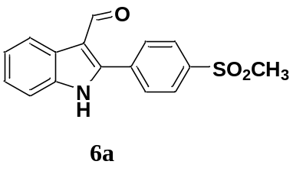
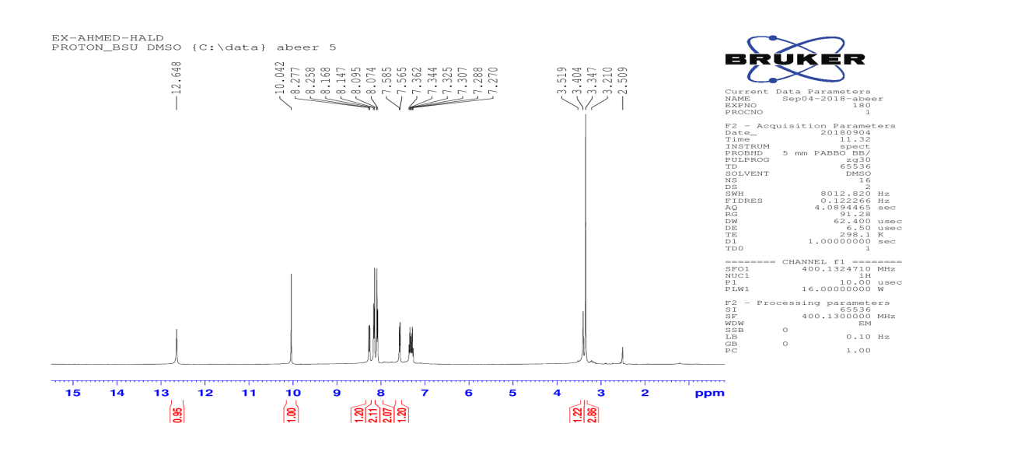
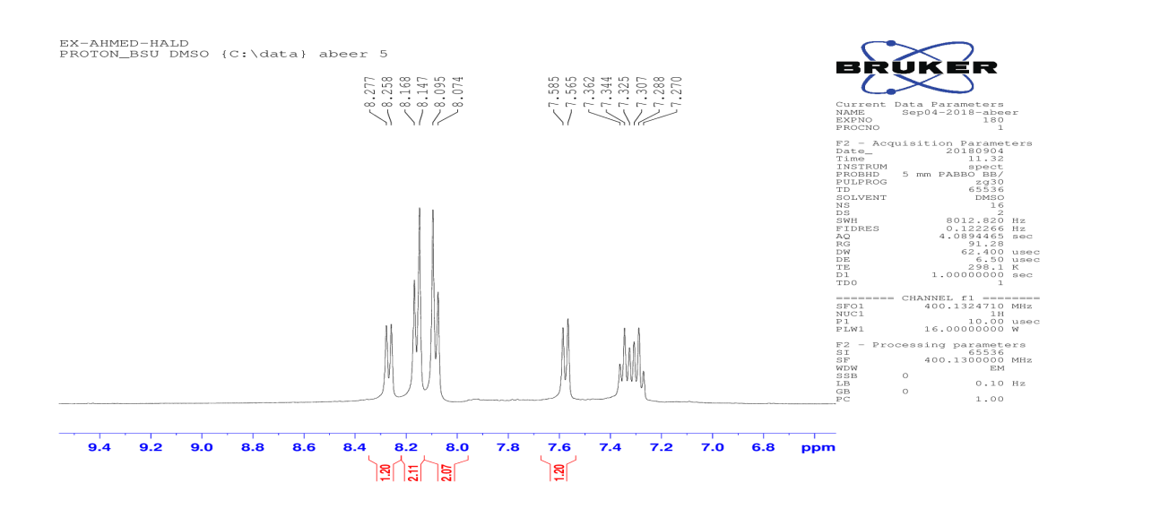
¹H NMR chart for compound 6a

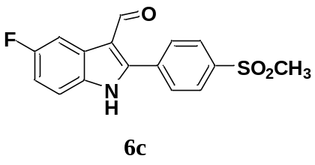
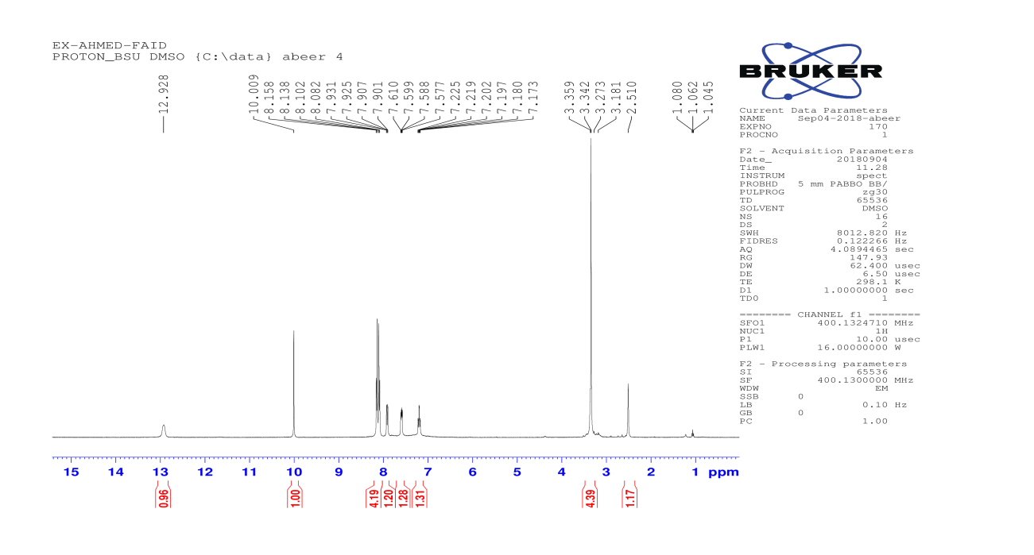
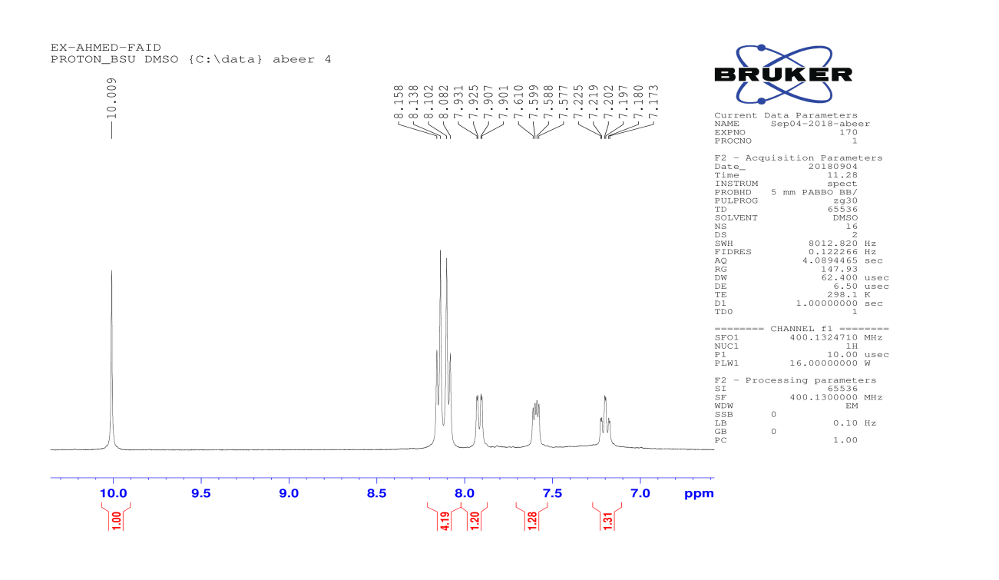
¹H NMR chart for compound 6c

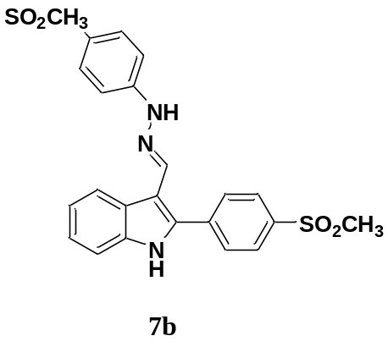
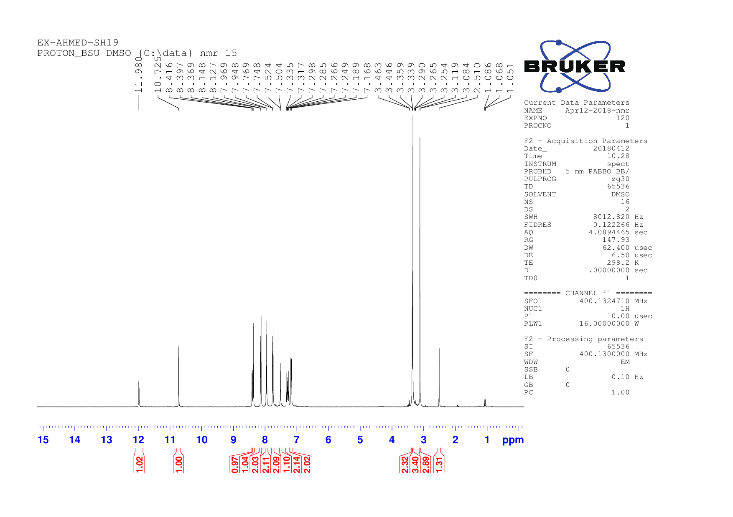
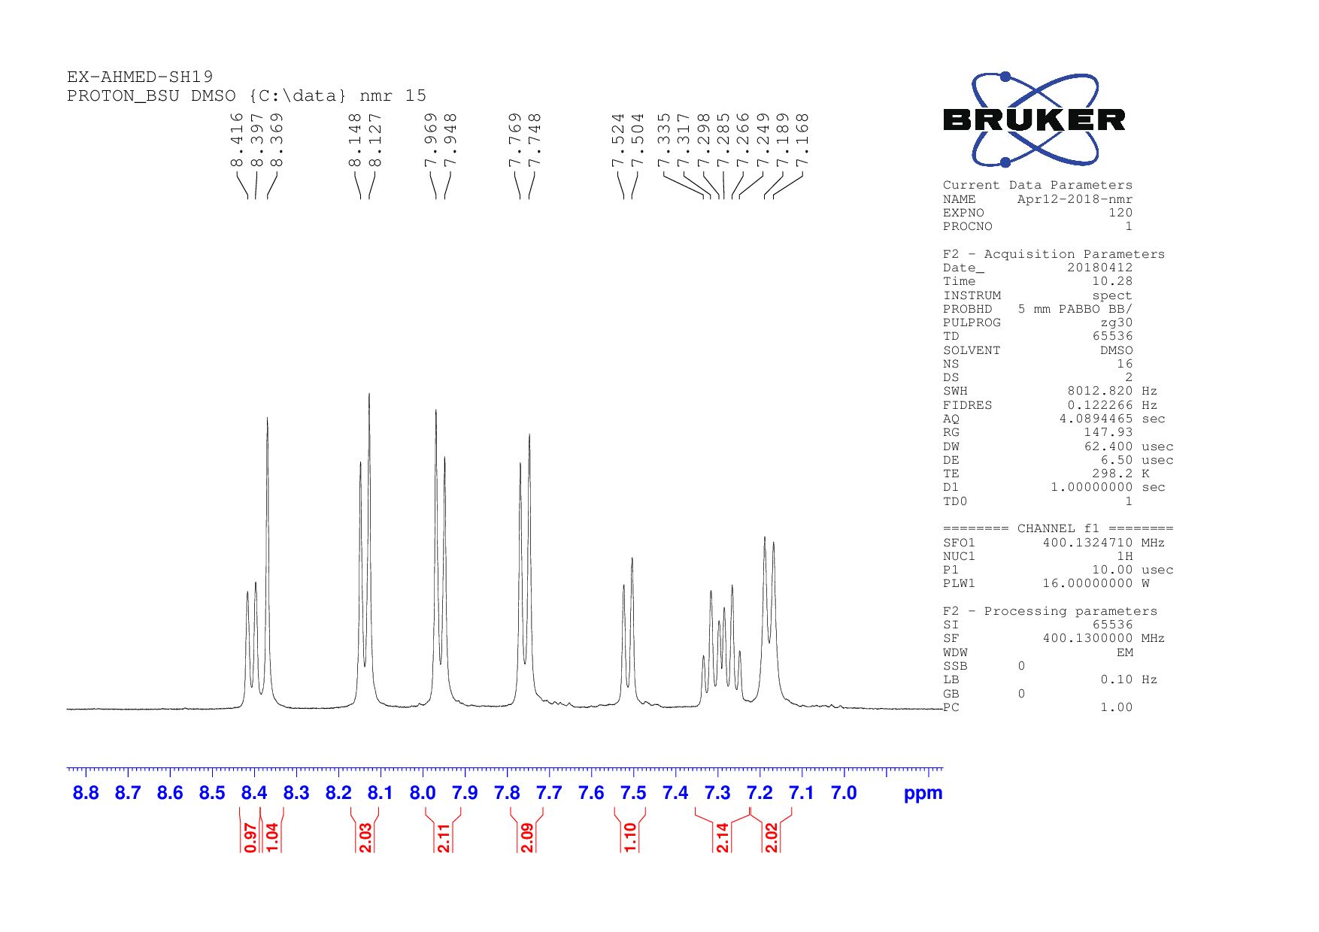
¹H NMR chart for compound 7b
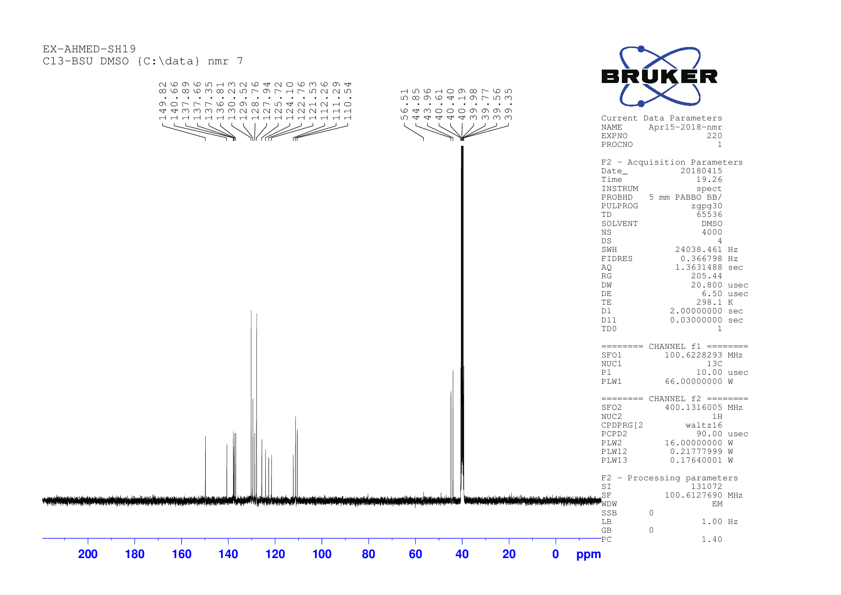
¹³C NMR chart for compound 7b

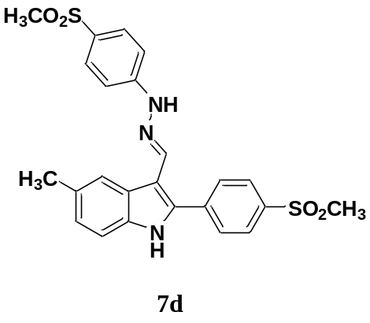
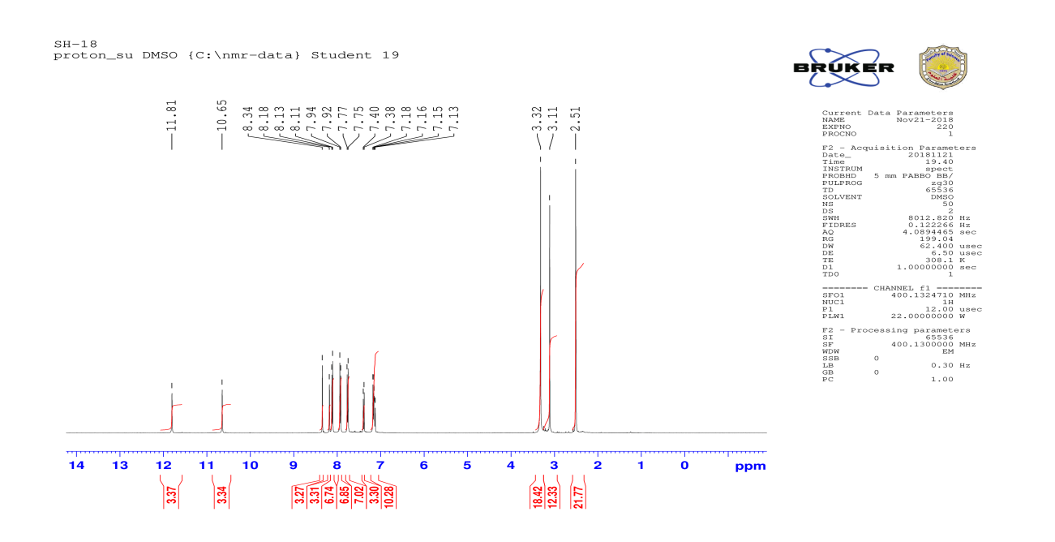
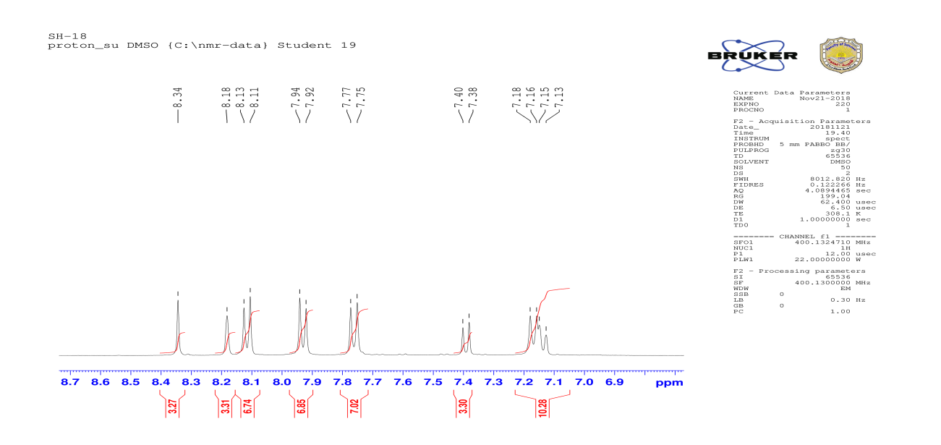
¹H NMR chart for compound 7d
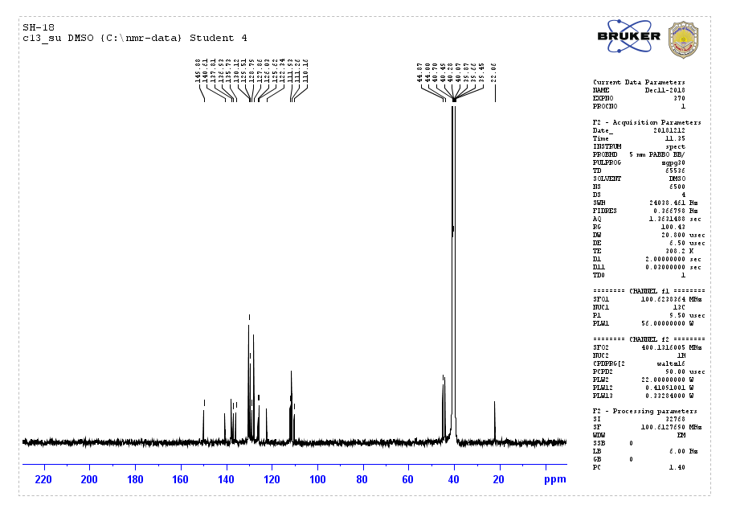
¹³C NMR chart for compound 7d

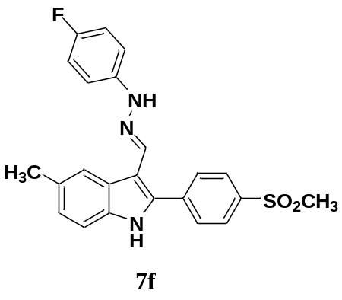
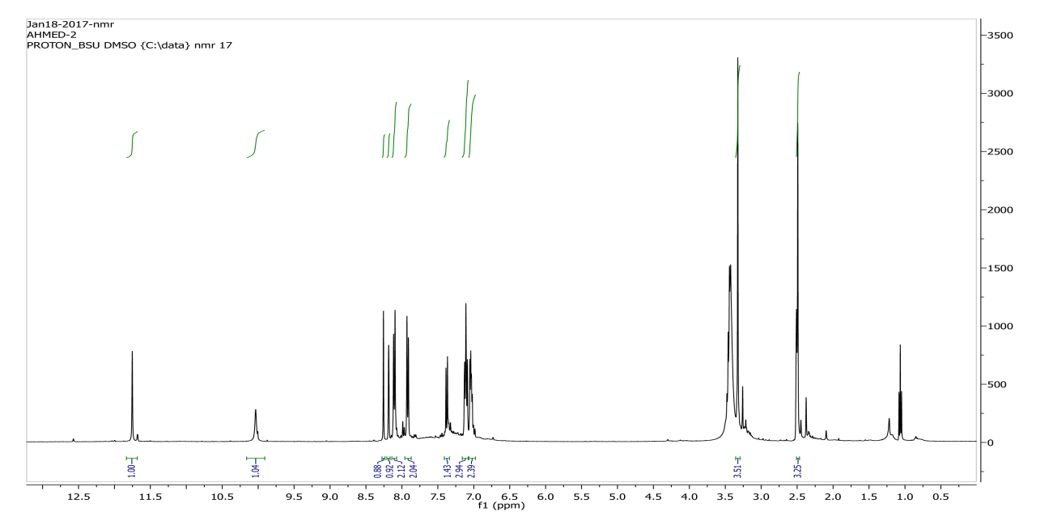
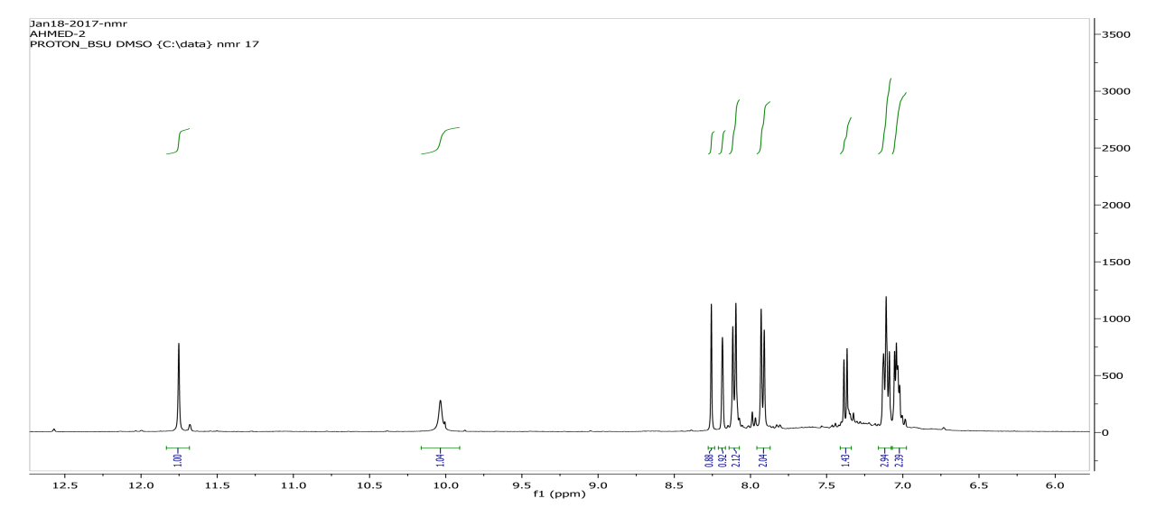
¹H NMR chart for compound 7f

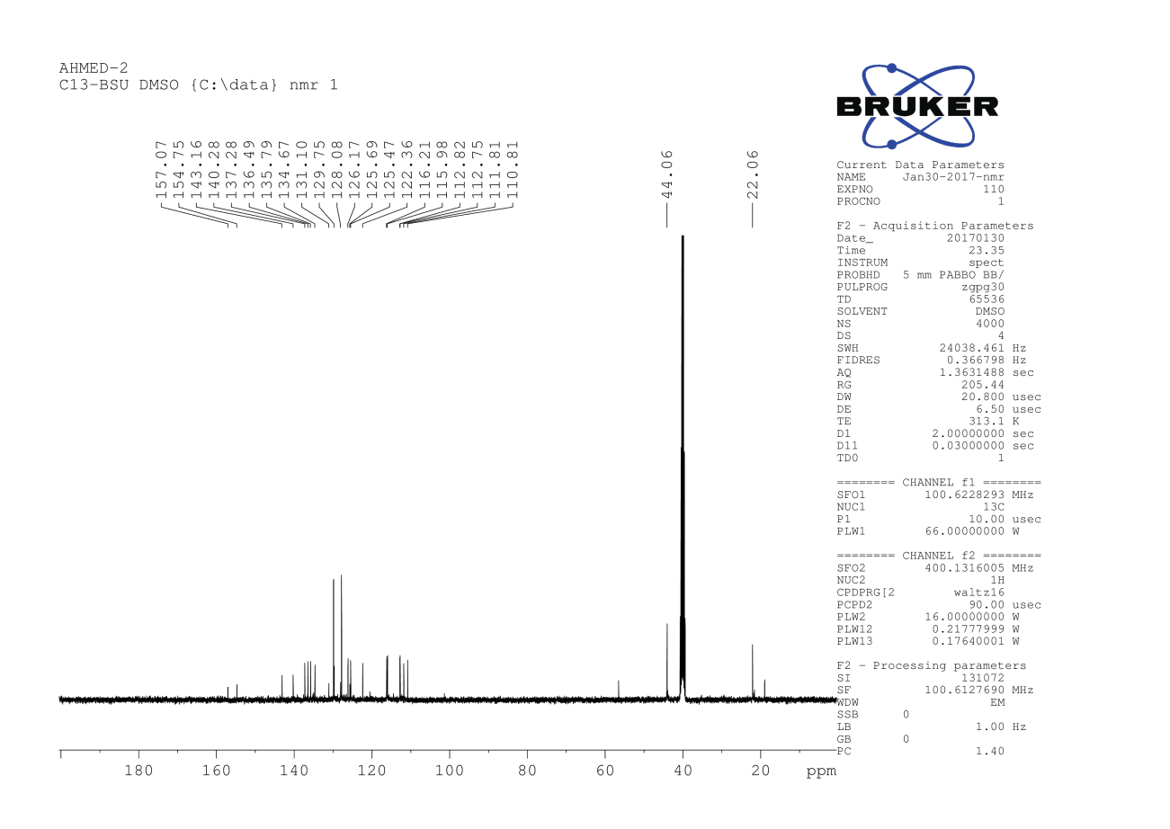
¹³C NMR chart for compound 7f

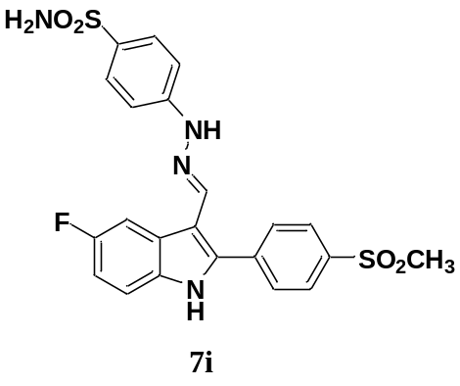
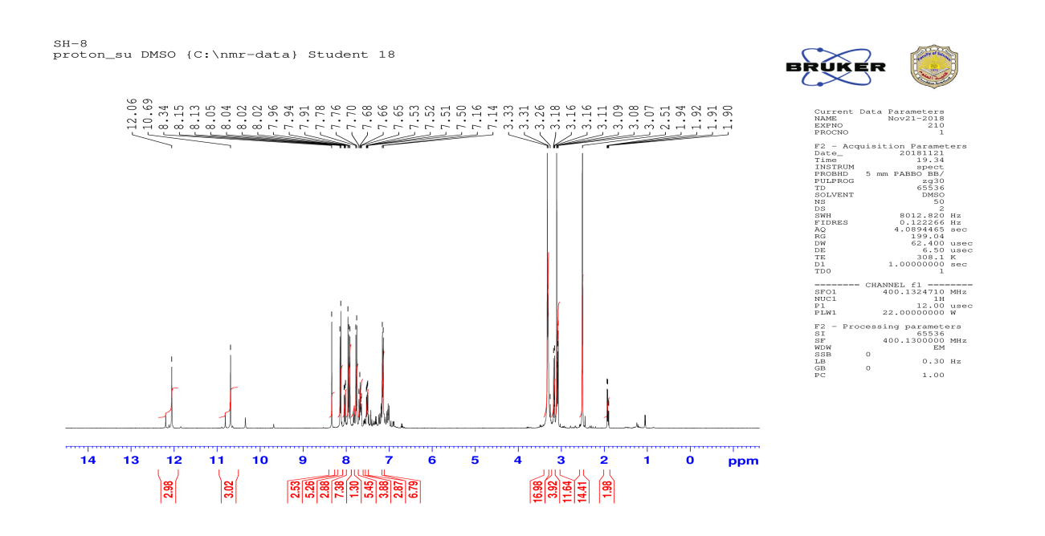
¹H NMR chart for compound 7i
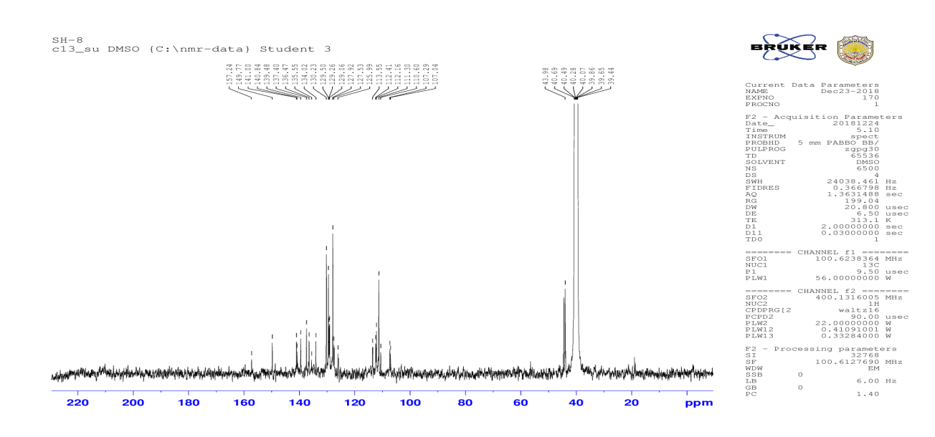
¹³C NMR chart for compound 7i
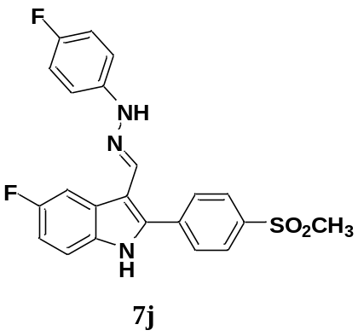
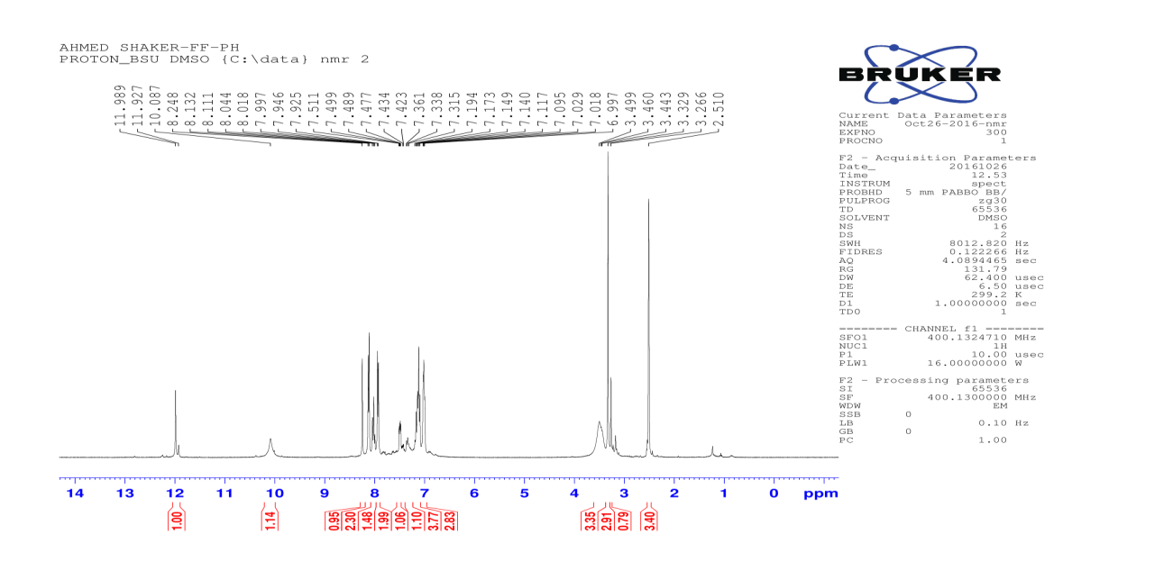
¹H NMR chart for compound 7j
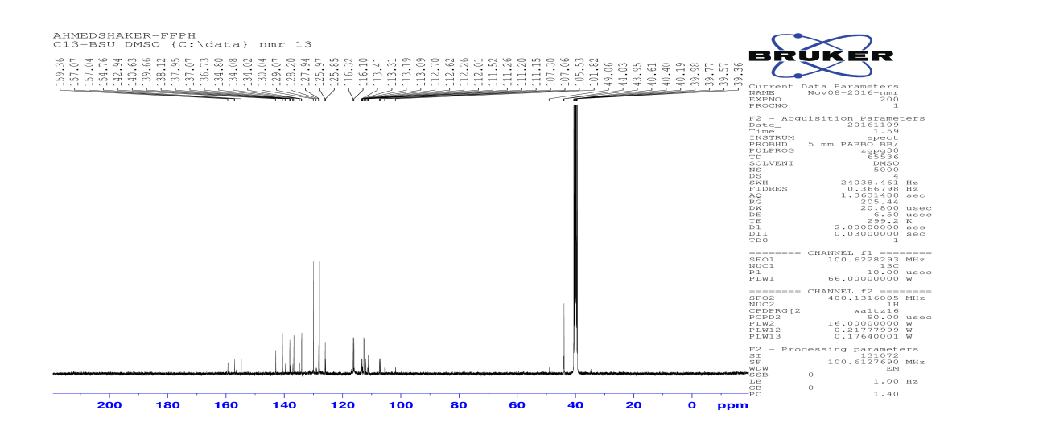
¹³C NMR chart for compound 7j

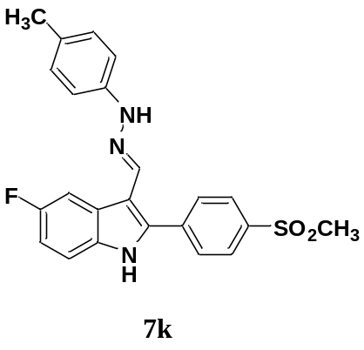
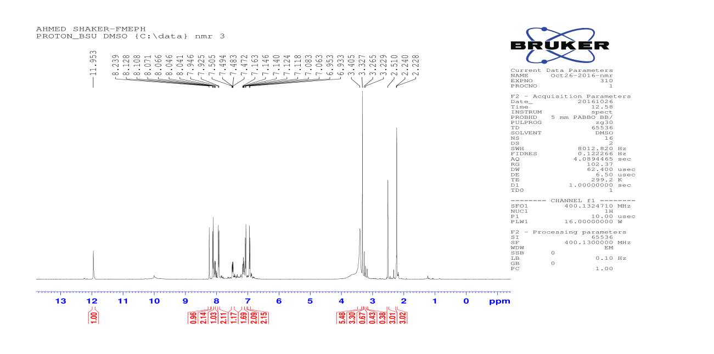
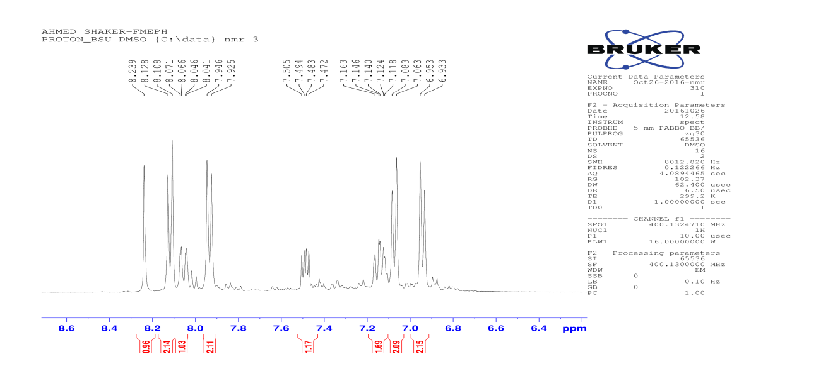
¹H NMR chart for compound 7k

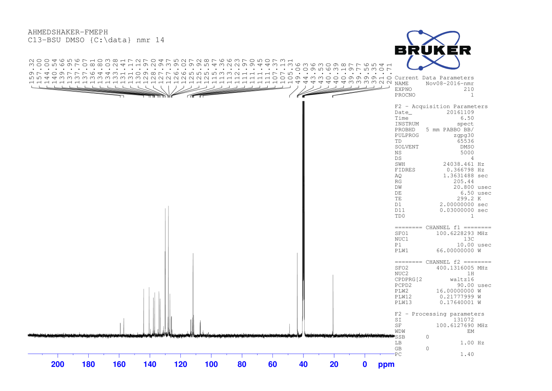
¹³C NMR chart for compound 7k

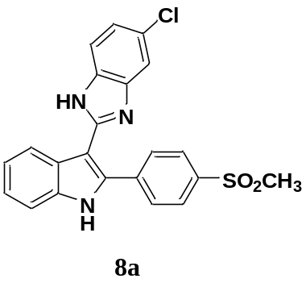
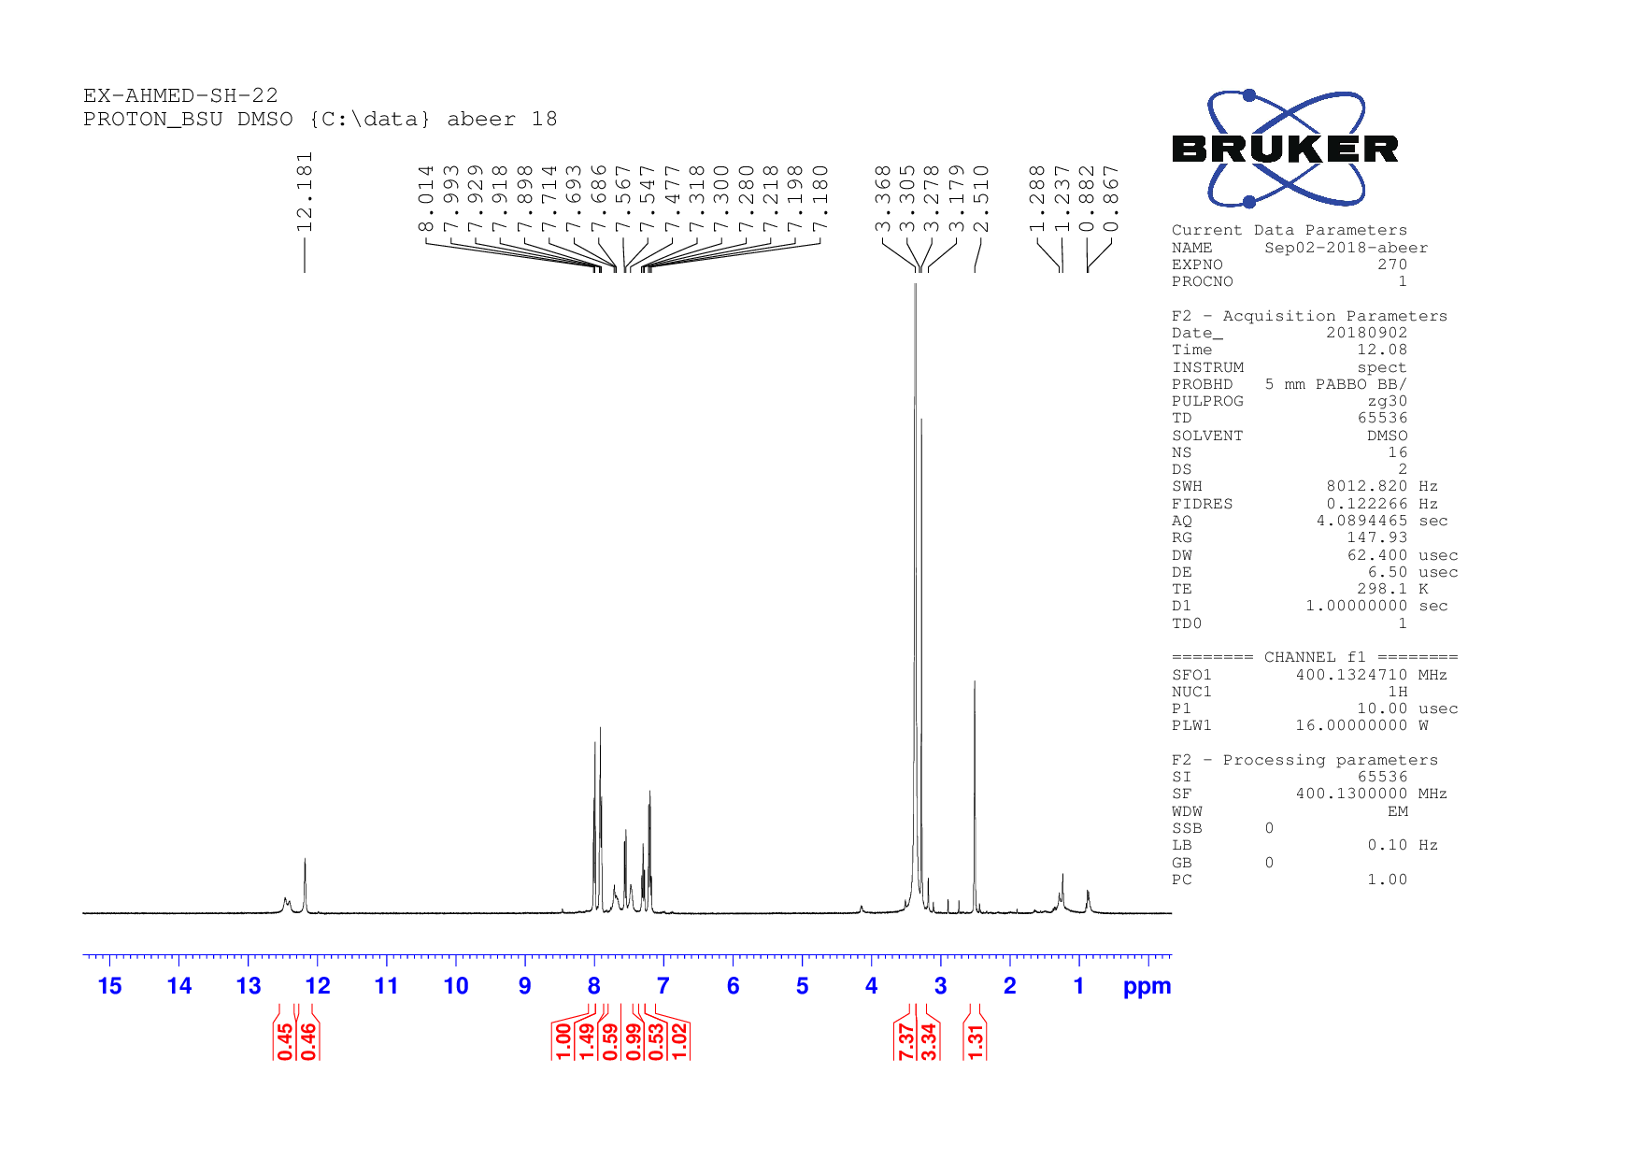
¹H NMR chart for compound 8a
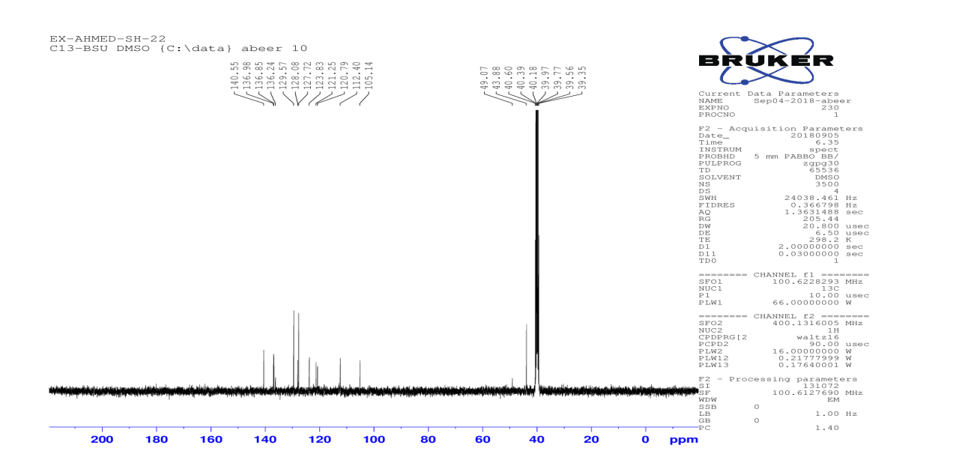
¹³C NMR chart for compound 8a
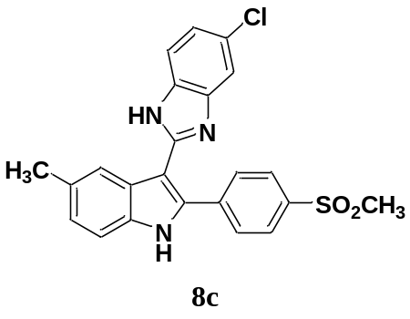
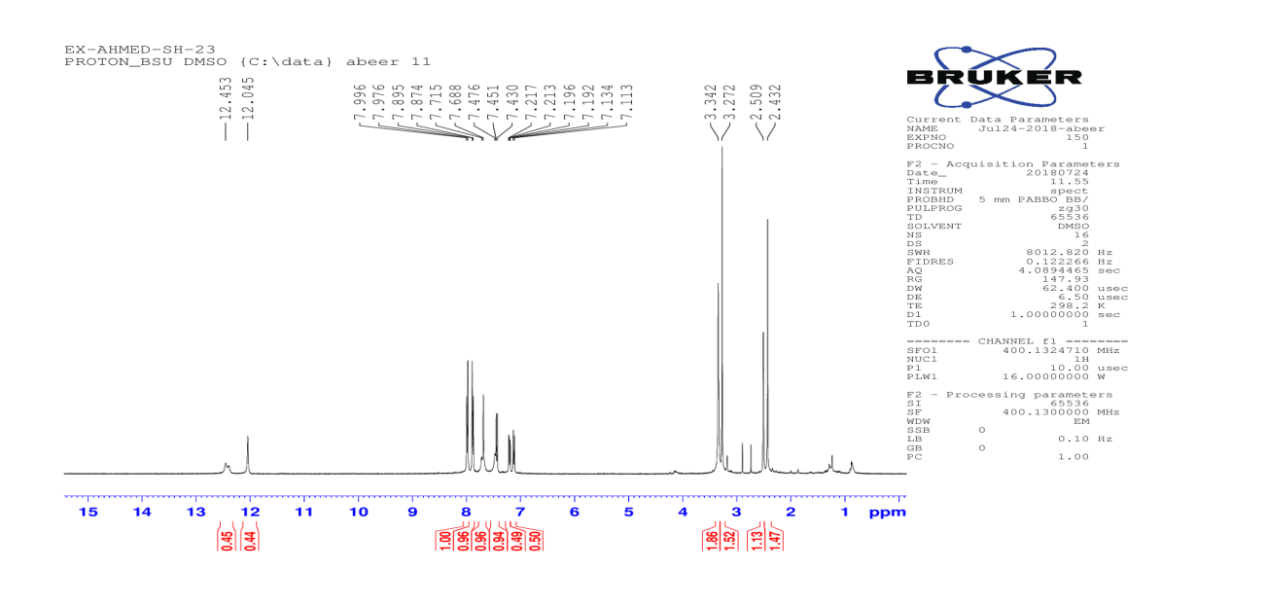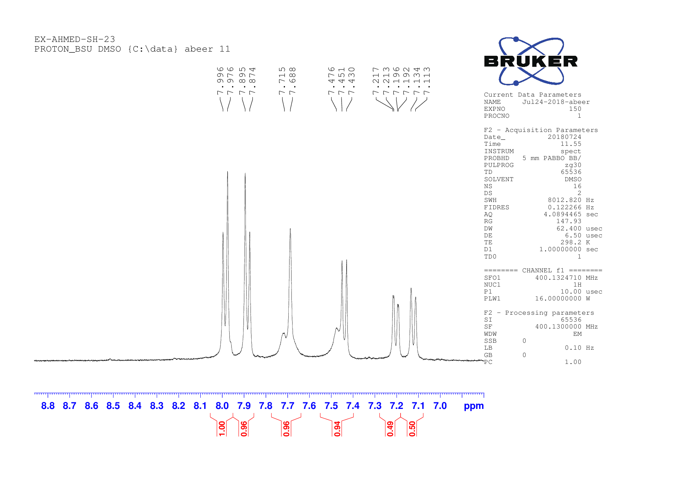
¹H NMR chart for compound 8c

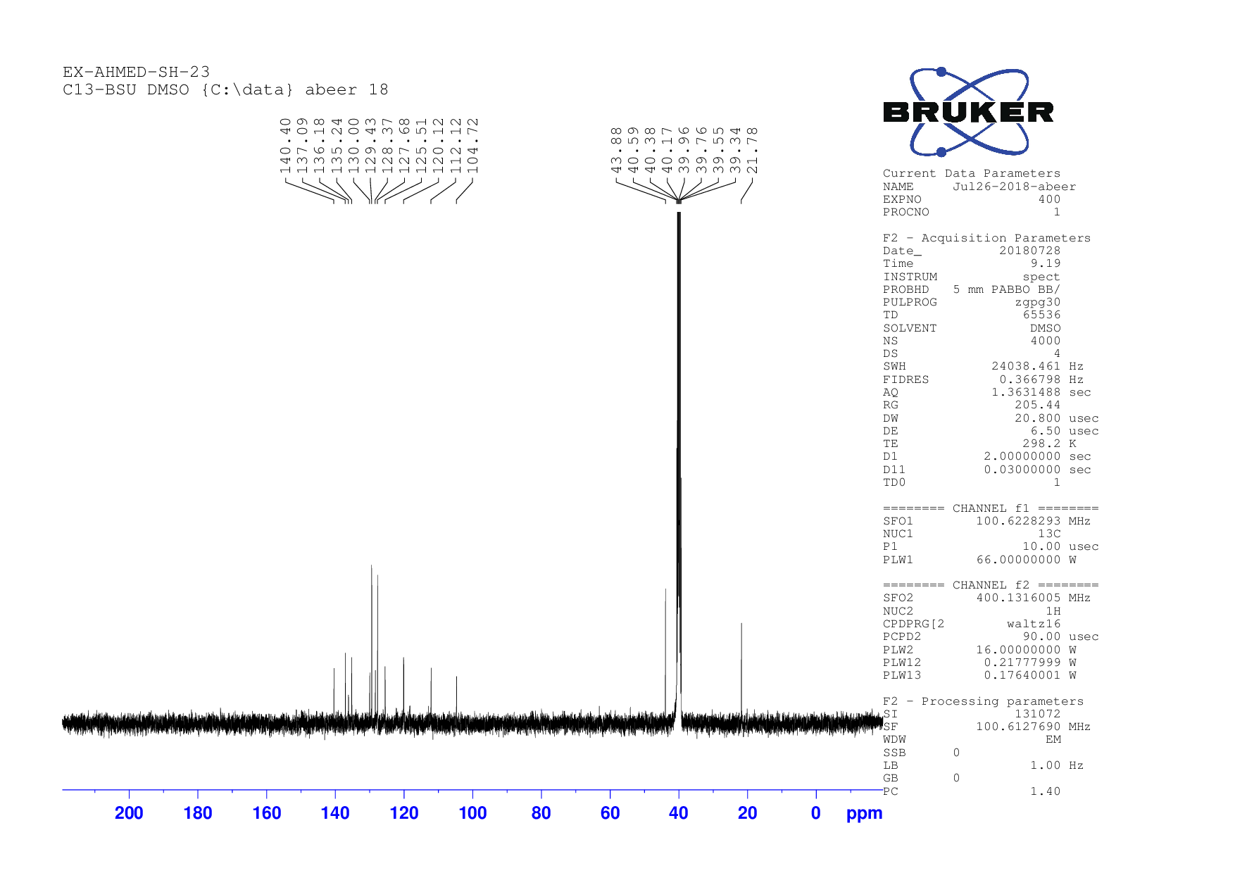
¹³C NMR chart for compound 8c

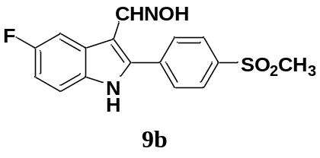
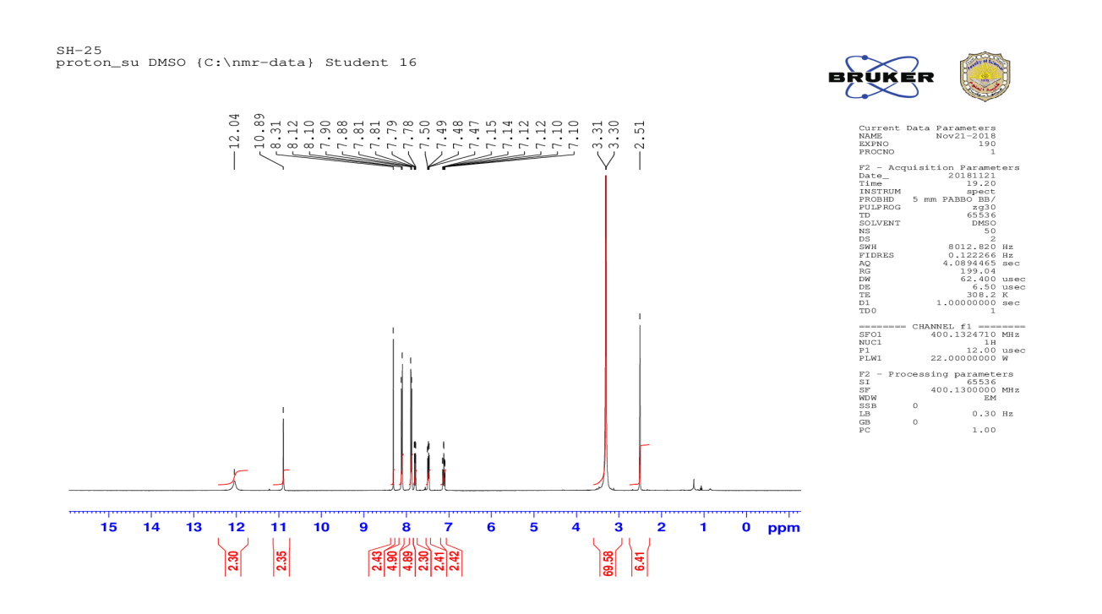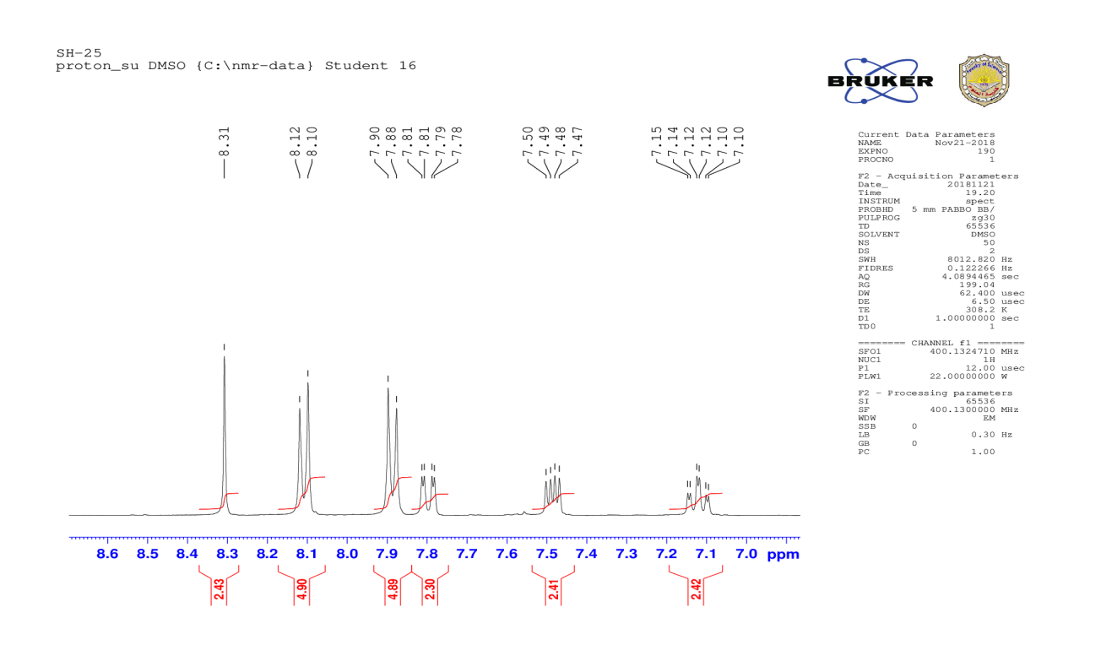
¹H NMR chart for compound 9b

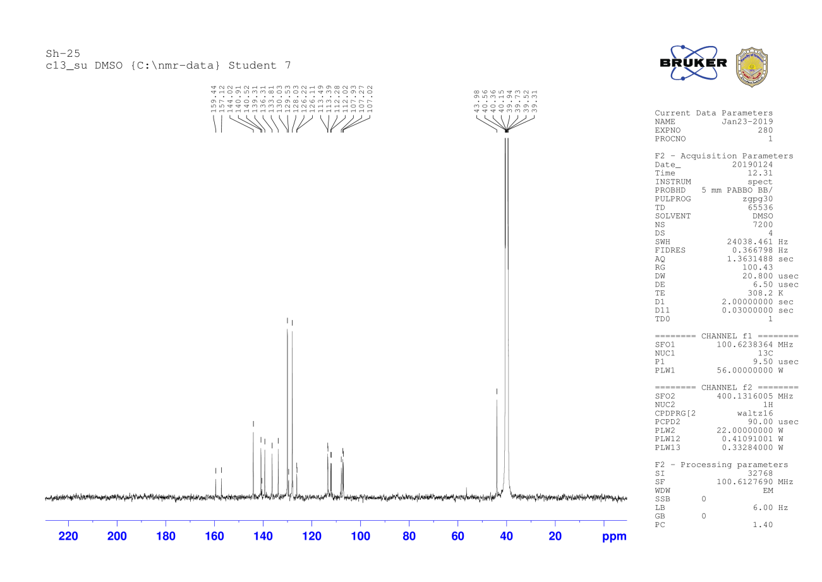
¹³C NMR chart for compound 9b

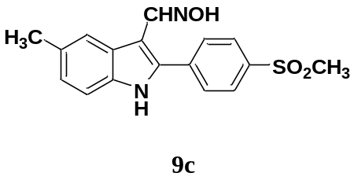
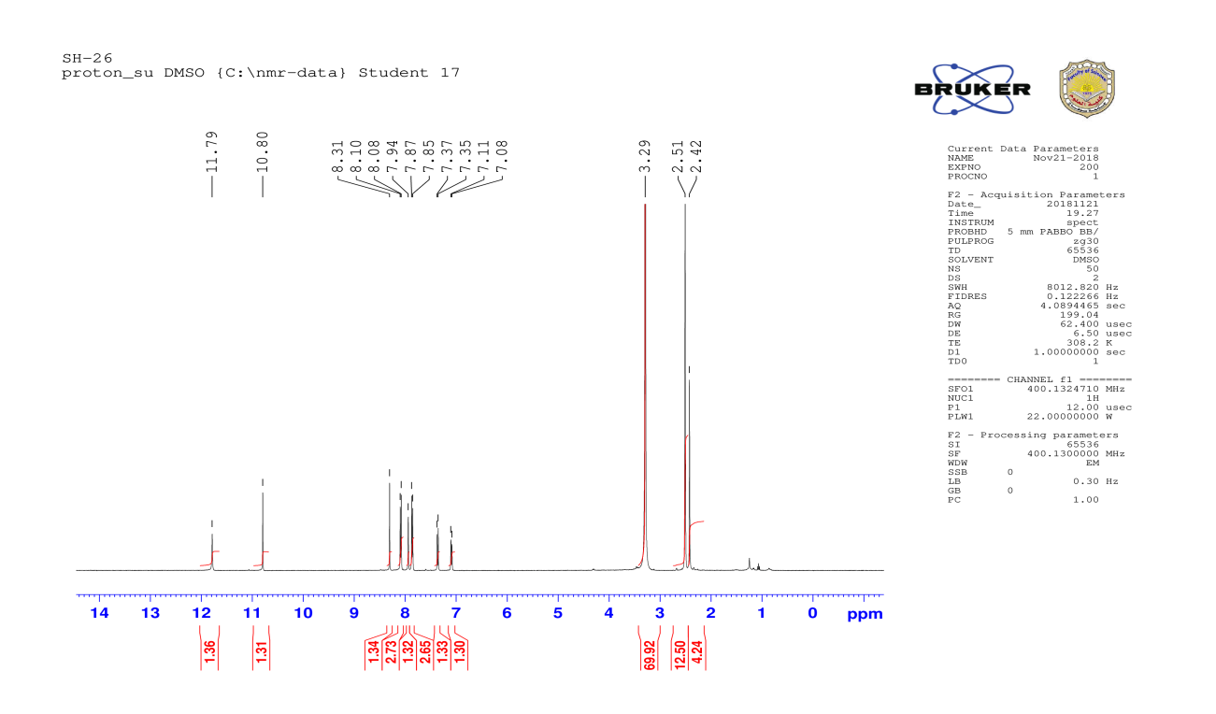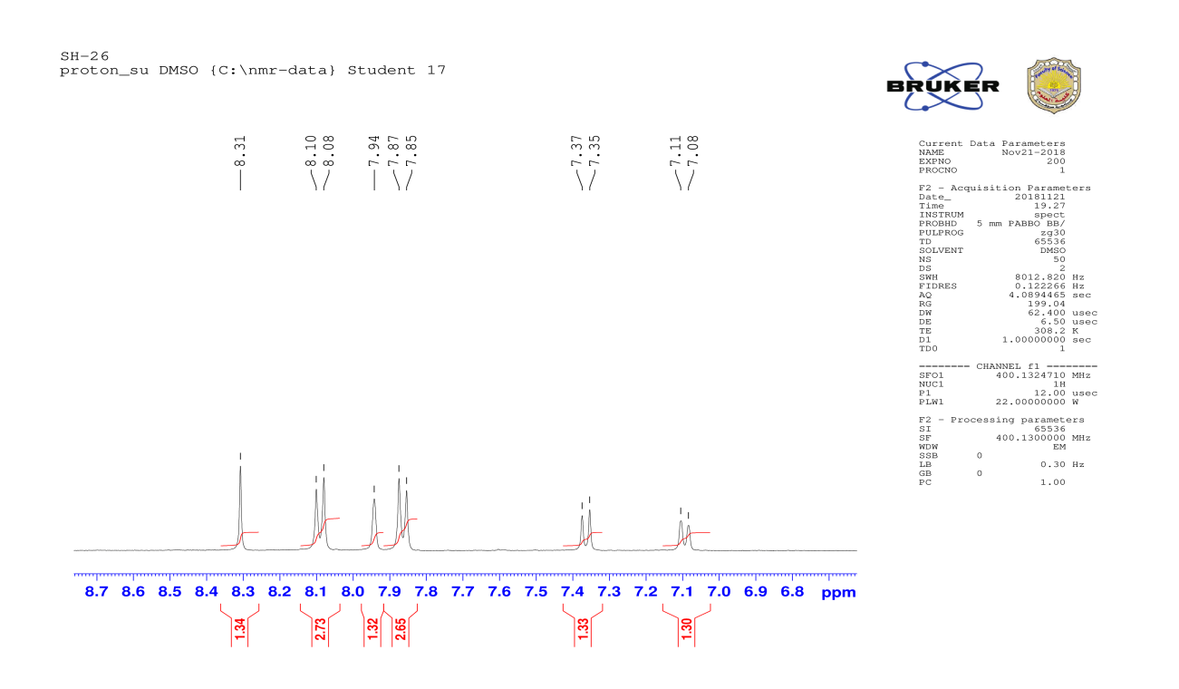
¹H NMR chart for compound 9c
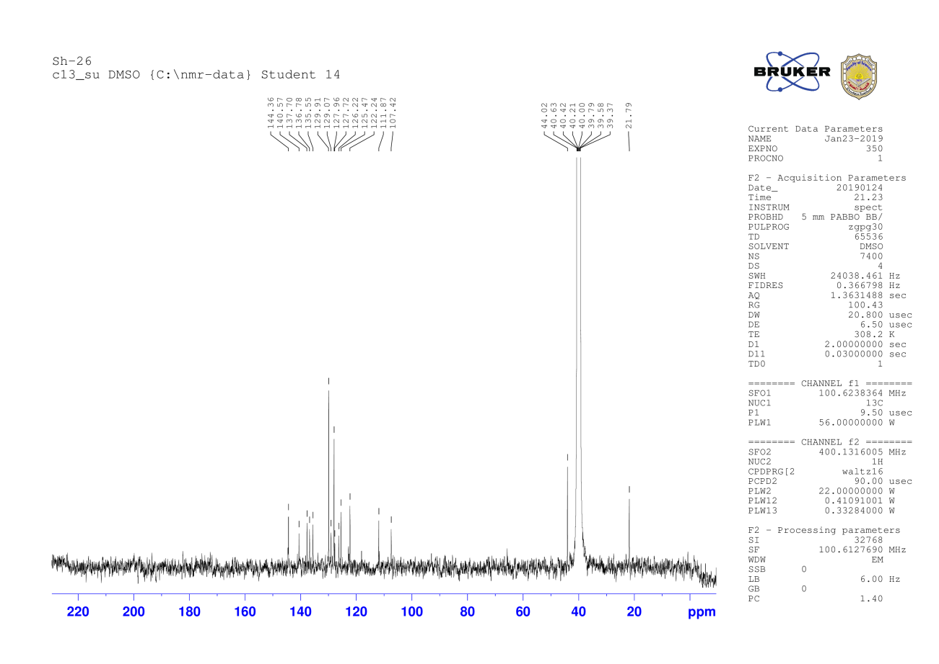
¹³C NMR chart for compound 9b

